

KURO – Information for invitation to tender

Product:
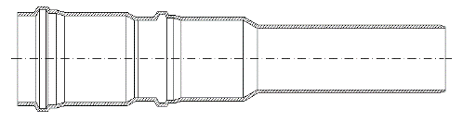

PVC transition socket for PE

Information for invitation to tender:

 | Pos:....................... | PVC Transition socket for PE as a sealing socket
From PVC 110mm to PE (smooth) 125mm
Colour: black / length= 497 mm
 |  | System KURO o. glw. (www.kuro-kunststoffe.de),
 |  | supply and install, as an addition to pos: ...........
 |  | Amount:............Pieces UP: ....... TP: ........

 | Pos:....................... | PVC Transition socket for PE as a sealing socket
From PVC 110mm to PE (smooth) 140 mm
Colour: black / length= 690 mm
 |  | System KURO o. glw. (www.kuro-kunststoffe.de),
 |  | supply and install, as an addition to pos: ...........
 |  | Amount:............Pieces UP: ....... TP: ........

